Roll No: 2003055

Lab Performance Evaluation 02
Lab Task Q[1]
Question:
8 bit register design

Solution (Code/Add all circuits diagrams):
1 bit register:
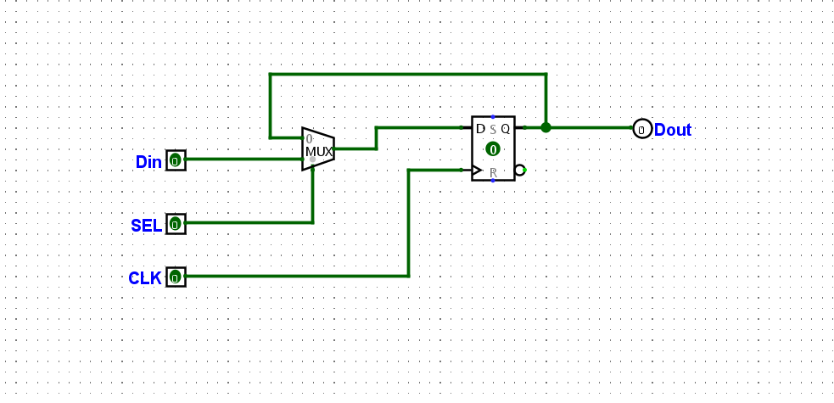

8 bit register:
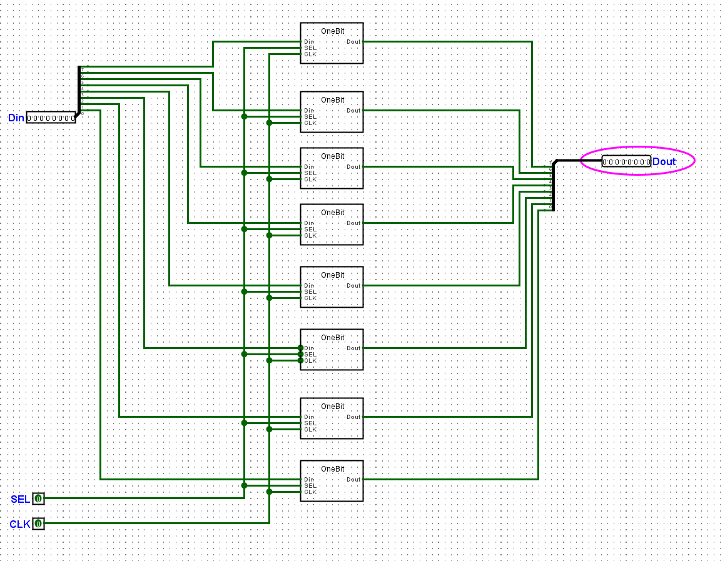

Flag:
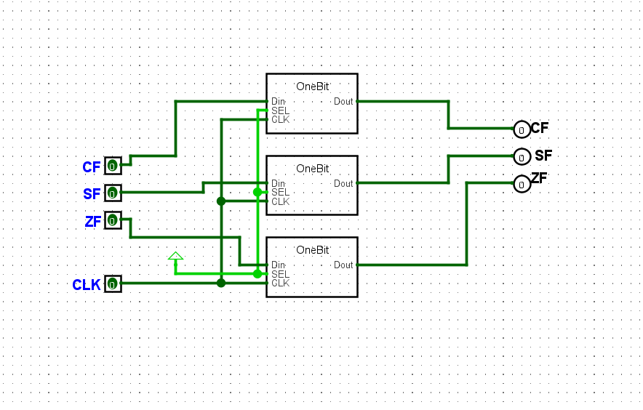

Output/Simulation Result (Screenshot/SnapShot):

